**Assisted Practice: 2.3 IIFEs, Callbacks, and Closures**

This section will guide you to:

* Create a JavaScript project in your IDE
* Write a program in JavaScript to create IIFEs, callbacks, and closures

This lab has three subsections, namely:

2.3.1 Writing a program in JavaScript to verify implementations of IIFEs, callbacks, and closures

2.3.2 Executing the program and verifying working of IIFEs with callbacks and closures

2.3.3 Pushing the code to your GitHub repositories

**Step 2.3.1:** Writing a program in JavaScript to verify implementations of IIFEs, callbacks, and closures

* Open Visual Studio Code
* *[Right click]* on the **src** folder of the project
* Select *New File* -> Enter the filename as **index.html**
* Write the code shown below resolving the warning and errors due compatibility-related issues

<html>

<body>

<h1>MEAN Stack</h1>

<p> Lesson 3 Demos </p>

<script src="IIFEs_Callbacks_Closures.js"></script>

</body>

</html>

* *[Right click]* on the **src** folder of the project
* Select *New File* -> Enter the filename as **IIFEs_Callbacks_Closures.js**
* Execute the code shown below resolving the warning and errors due compatibility-related issues

//IIFE and Closure

const empId = (function() {

let count = 0;

return function() {

++count;

return `emp${count}`;

};

})();

console.log("New Emplyee IDs are listed here");

console.log("Alex: "+empId());

console.log("Dexter: "+empId());

console.log("Annie: "+empId());

//Callbacks

console.log("\n"); //to start the output from the neext line

function fullName(firstName, lastName, callback){

console.log("My name is " + firstName + " " + lastName);

callback(lastName);

}

var greeting = function(ln){

console.log('Welcome ' + ln);

};

fullName("Alex", "Wilson", greeting);

console.log("\n");

fullName("Dexter", "Johnson", greeting);

console.log("\n");

fullName("Annie", "Butler", greeting);

**Step 2.3.2:** Executing the program and verifying working of IIFEs with callbacks and closures

Before you execute the program, check for syntactical corrections. If no errors are found, follow the steps mentioned below:

* Go to Extensions and download **Live Server**
* *[Right click]* on the **index.html** file of the project
* Select *Open with Live Server*
* Right click when the server starts running. Select *Inspect*.Click on **Console**

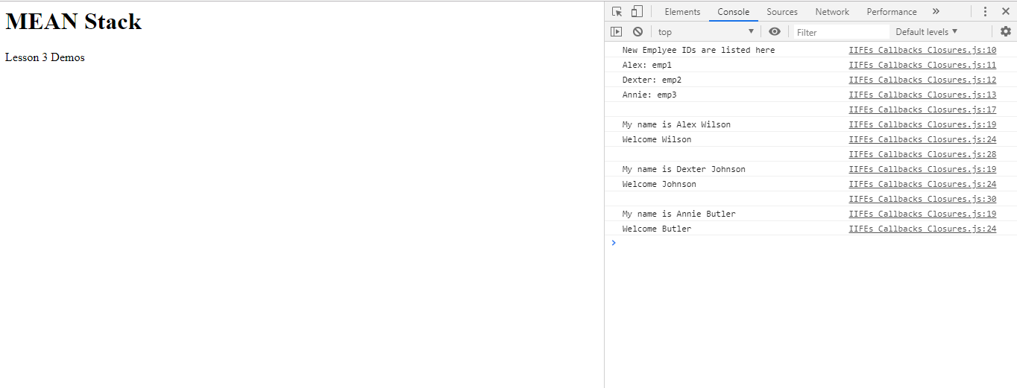

**Step 2.3.3:** Pushing the code to your GitHub repositories

* Open your command prompt and navigate to the folder where you have created your files.

**cd <folder path>**

* Initialize your repository using the following command:

**git init**

* Add all the files to your git repository using the following command:

**git add .**

* Commit the changes using the following command:

**git commit . -m “Changes have been committed.”**

* Push the files to the folder you initially created using the following command:

**git push -u origin master**